Edward Auttonberry

**Lab 1: Using the Vernier Lab Pro Interface and the Logger Pro Data Collection Software**

3/16/2018

PHYS 261 – 005

With:

Paige Meeks

and

Stella Li

**Objective**

The objective of this lab for us was to familiarize ourselves with interfacing with the Lab Pro using the Logger Pro collection software. We were to become familiar with the processes of finding the average value in a set of continuous data and finding the standard deviation about that average. We were also to learn the user interfaces and tools for Excel and Logger Pro, such as graphs and tables in the former, and the Statistic and Linear fit tools in the latter.

**Theory**

The theory being tested in this is that the temperature of an object will change at a rate proportional to the difference in temperature between the source of heat and another object. To do this, we needed to know the temperature of the thermometer rod at equilibrium with the room temperature, the temperature of the object that sources the heat (a hand), and we will need to measure the temperature of the thermometer as it increases during contact with the heat source. Using the data, we would find the standard deviation over the set of data.

**Procedure**

The procedure for this lab involved the Lab-Pro measurement tool and the Logger Pro software, and a thermometer rod connected to the Lab-Pro, the temperature of which is being measured. Using these utilities, two separate sets of data were recorded. For the first set of data, we let the thermometer alone while the Lab-Pro collected two measurements a second for 50 seconds. For the second set, we let the Lab-Pro collect at the same rate for 200 seconds. We left the thermometer alone for about 10 seconds to get a clear idea of where the equilibrium temperature stands to compare with the rest of the data collected. After that, one of us grabbed the thermometer firmly with our hand for the remained of the collection duration.

**Data**

**Set A:**

Shown below is the results of the first measurement in Logger-Pro

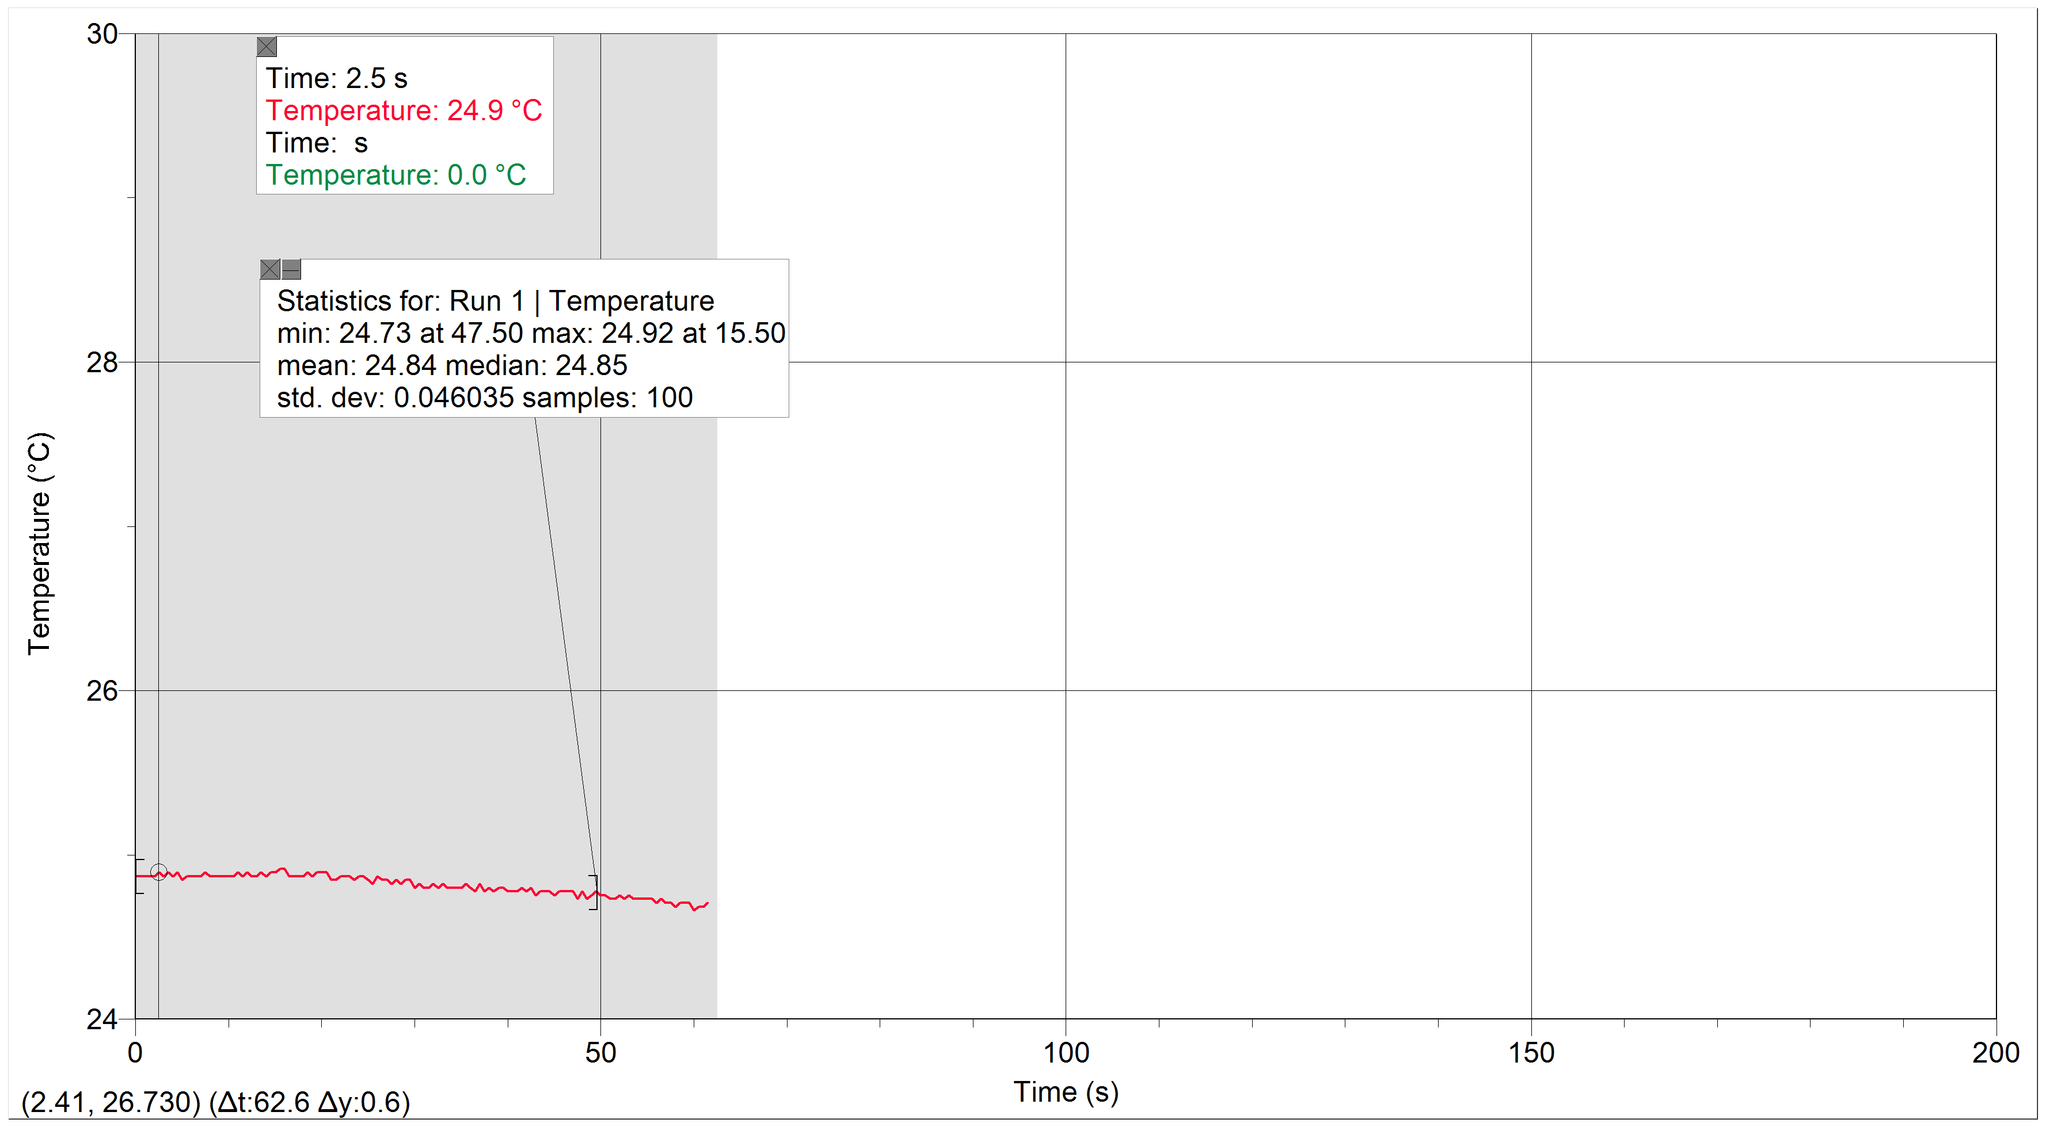

Note that the duration of the set exceeds fifty seconds, but we only used the first fifty seconds of data in our calculations. The temperature also seems to decrease a bit, but there was no physical change in the state of the thermometer throughout the duration of the collection.

Here is a sample from the excel spreadsheet of the logger-pro readings and the calculations done therein.

|  |  |  |  |
| --- | --- | --- | --- |
| Time (s) | T (°C) | T-Tavg | (T-Tavg)^2 |
| 0 | 24.86957709 | 0.032920207 | 0.00108374 |
| 0.5 | 24.86957709 | 0.032920207 | 0.00108374 |
| 1 | 24.86957709 | 0.032920207 | 0.00108374 |
| 1.5 | 24.86957709 | 0.032920207 | 0.00108374 |
| 2 | 24.86957709 | 0.032920207 | 0.00108374 |
| … | … | … | … |
| 47.5 | 24.73047484 | -0.106182042 | 0.011274626 |
| 48 | 24.77684427 | -0.059812615 | 0.003577549 |
| 48.5 | 24.73047484 | -0.106182042 | 0.011274626 |
| 49 | 24.75365982 | -0.082997068 | 0.006888513 |
| 49.5 | 24.77684427 | -0.059812615 | 0.003577549 |
| sum= | 2483.665688 | sum= | 0.209801734 |
| Tavg= | 24.83665688 | σ (calc)= | 0.046034872 |
| Excel avg= | 24.83665688 | Excel σ= | 0.046034872 |

**Set B:**

Here is the graph of the Logger-Pro results for the second set of readings.

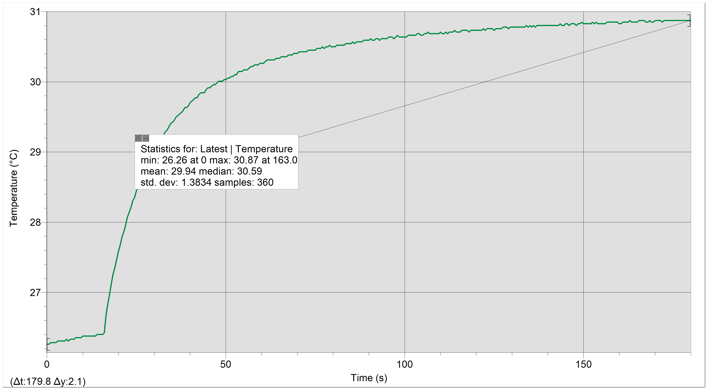

Here is the table of calculations for the differences between slopes in the curve of the graph.

|  |  |  |  |
| --- | --- | --- | --- |
| Temp of hand |  |  |  |
| 30.87283848 |  |  |  |
|  |  |  |  |
| Region | mean C | T hand - mean C | slope C/sec |
| 1 | 27.67 | 3.202838483 | 0.2028 |
| 2 | 29.02 | 1.852838483 | 0.0952 |
| 3 | 29.7 | 1.172838483 | 0.04759 |
| 4 | 30.04 | 0.832838483 | 0.02522 |
| 5 | 30.27 | 0.602838483 | 0.01775 |
| 6 | 30.41 | 0.462838483 | 0.01161 |
| 7 | 30.47 | 0.402838483 | 0.00762 |
| 8 | 30.59 | 0.282838483 | 0.006408 |

And a plot of the slope versus the difference between the temperature of the heat source and the average temperature of the regions.

**Analysis**

**Set A**

The data retrieved for this first set is the temperature of the thermometer stick over 50 seconds, where the thermometer was left in a static position during the duration. An average of the set of data was taken and deviations were calculated for each result using the deviation formula. For example, the first result in the deviations (T – Tavg) would have been:

$$24.86957709 °C-24.83665688 °C=0.032920207 °C$$

Then the variances were taken using the variance formula. Using the same row of results, we would get:

$${\left(0.032920207 °C\right)}^{2}=0.00108374 °C$$

The standard deviation was found using the sum of the variances as shown:

$$\sqrt{\frac{0.00108374+0.00108374+…+0.006888513+0.003577549 }{50-1}}$$

Which came out to be 0.046034872 = σ.

The purpose of this was to show that the temperature changes would be very small when no heat source is contacting the thermometer.

**Set B**

The data retrieved for the second set is the temperature of the thermometer stick over 200 seconds, where about the latter 190 seconds of the duration is driven by contact with a heat source (a hand). We eyeballed eight regions in the curve where we would take averages of the temperature in those regions, find the difference between those averages and the temperature of the heat source, and plot the average slope in those regions against that difference. The purpose of this is to show that the temperature of the thermometer will increase at an exponential rate until it approaches the temperature of the heat source. The Logger-Pro results give a good visualization of this phenomenon. And the plot Slope vs. Temperature difference shows that as the average temperature in a region gets higher, the slope in that region gets lower. This shows that the slope is leveling out.

**Conclusions**

The goal of the lab was to show that the temperature of a cooler object will increase at an exponential rate to match the temperature of a warmer object in contact until approaching a limit. Set A shows that an object without contact does not change temperature. The small changes in the temperature for that set were caused by fluctuations in air current and generally unreliable reading caused by the analogue signal from the thermometer rod. Overall, the trend in set A was level, so it shows this point well. Set B’s data shows that once an object encounters a warm source, its temperature increases exponentially until approaching a limit, which is demonstrated well by the data and calculations provided. Because the temperature of the thermometer did not change when there was no contact, and did change with an initially steep slope upon contact, I conclude that the goal of the lab was reached, and the temperature of objects increase exponentially to match that of warmer objects.